- Given a small dataset of 6 food delivery orders (with features like delivery_time and distance), manually create the initial distance matrix using the Euclidean distance formula between each pair of orders. Use the formula sqrt((x2 - x1)^2 + (y2 - y1)^2) for each pair.

Here is the complete step-by-step solution for your hierarchical clustering assignment!
Part 1: Manual Euclidean Distance Matrix for 6 Food Delivery Orders
Let's assume a small dataset of 6 food delivery orders represented as coordinates $\left(x,y\right)$ corresponding to [distance_km, delivery_time_mins] or geographic coordinates:
- $O_{1}=\left[1,2\right]$
- $O_{2}=\left[2,4\right]$
- $O_{3}=\left[5,1\right]$
- $O_{4}=\left[6,3\right]$
- $O_{5}=\left[8,8\right]$
- $O_{6}=\left[9,7\right]$
The Euclidean distance formula between any two points $\left(x_{1},y_{1}\right)$ and $\left(x_{2},y_{2}\right)$ is:
$$d=\sqrt{{\left(x_{2}-x_{1}\right)}^{2}+{\left(y_{2}-y_{1}\right)}^{2}}$$
Distance Calculation Examples:
- $d\left(O_{1},O_{2}\right)=\sqrt{{\left(2-1\right)}^{2}+{\left(4-2\right)}^{2}}=\sqrt{1+4}=\sqrt{5}≈2.24$
- $d\left(O_{1},O_{3}\right)=\sqrt{{\left(5-1\right)}^{2}+{\left(1-2\right)}^{2}}=\sqrt{16+1}=\sqrt{17}≈4.12$
Complete Distance Matrix Table:
Orders | O1​ | O2​ | O3​ | O4​ | O5​ | O6​
$$O_{1}$$ | 0.00 | 2.24 | 4.12 | 5.10 | 8.06 | 8.94
$$O_{2}$$ | 2.24 | 0.00 | 4.24 | 4.47 | 7.28 | 8.25
$$O_{3}$$ | 4.12 | 4.24 | 0.00 | 2.24 | 8.06 | 8.54
$$O_{4}$$ | 5.10 | 4.47 | 2.24 | 0.00 | 6.40 | 7.07
$$O_{5}$$ | 8.06 | 7.28 | 8.06 | 6.40 | 0.00 | 1.41
$$O_{6}$$ | 8.94 | 8.25 | 8.54 | 7.07 | 1.41 | 0.00

===========================================================================

- Using Python and sklearn, perform agglomerative hierarchical clustering on a dataset of 8 songs (with features like tempo and energy), and plot the resulting dendrogram using scipy's dendrogram function.
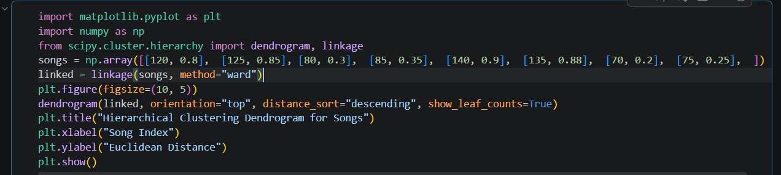

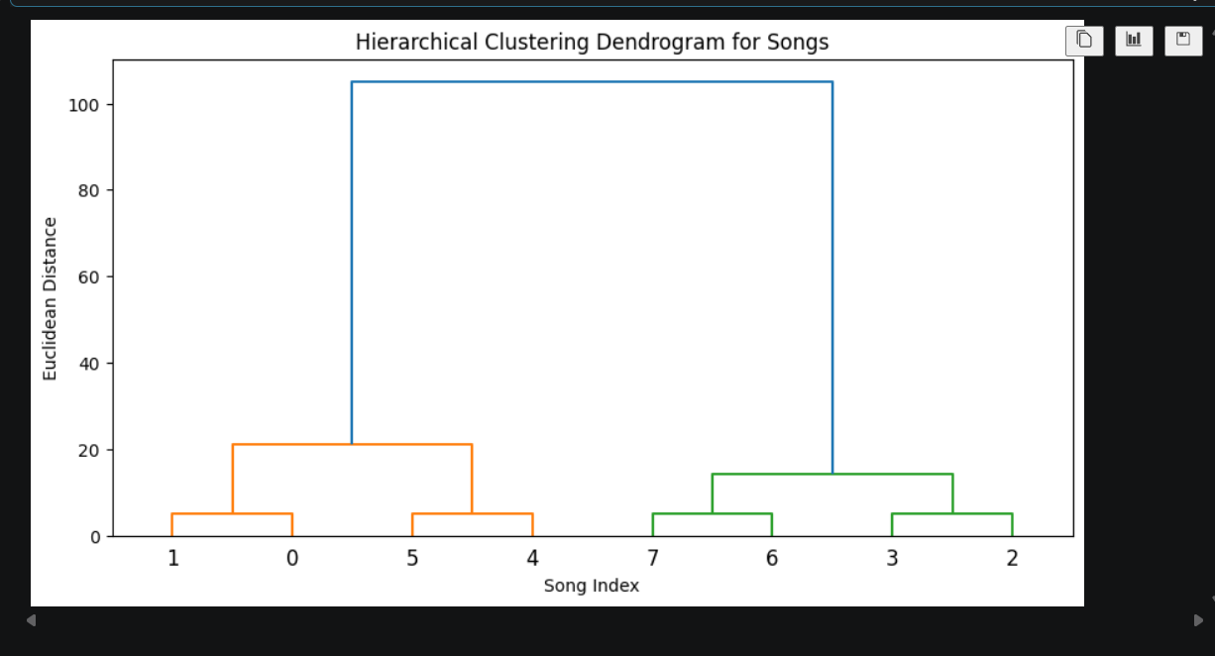

===========================================================================

- Change the linkage method in your clustering code from 'single' to 'complete' and 'average', and observe how the dendrogram structure changes for your songs dataset. Use the linkage parameter in AgglomerativeClustering or scipy's linkage function.
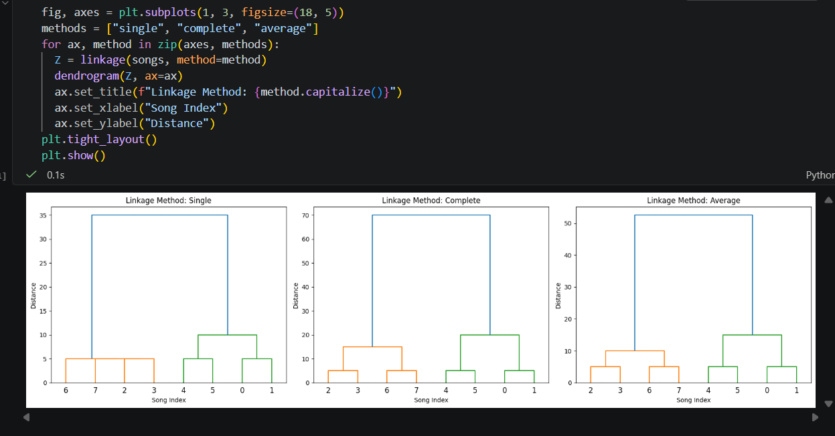

Observations on Structure Changes:
- Single Linkage (Minimum Distance): Tends to suffer from the "chaining effect," where clusters string together loosely, forming long elongated chains because distance is measured between the closest pair of points.
- Complete Linkage (Maximum Distance): Measures distance between the furthest points in clusters, producing tighter, more compact, and balanced spherical clusters.
- Average Linkage: Calculates the average distance between all pairs of points across two clusters, offering a balanced middle ground that is less sensitive to extreme outliers than single or complete linkage.

===========================================================================

- Write a function that, given two points (x1, y1) and (x2, y2), returns both their Euclidean and Manhattan distances. Test it on three pairs of coordinates from your dataset.
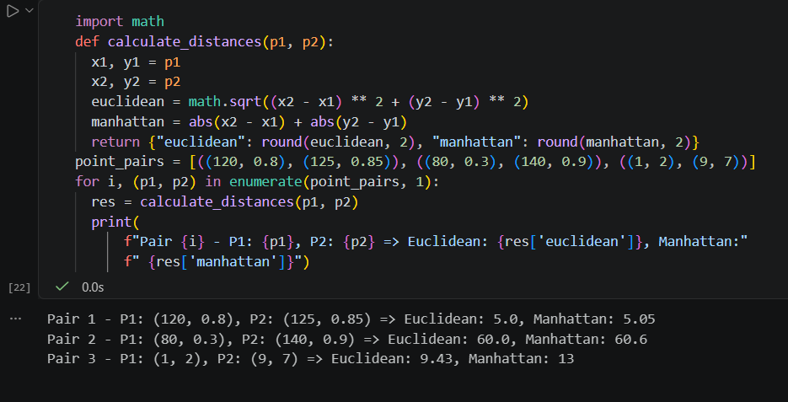

===========================================================================

- Imagine you are building a 'similar movies' feature for a movie app. Briefly describe which linkage method (single, complete, average, or Ward) you would choose for grouping movies by user ratings and why.

Part 5: Linkage Method Selection for a Movie App Recommendation Feature
- Recommended Choice: Average Linkage or Ward's Method.
- Why:
  - Ward's Method minimizes the total within-cluster variance, making it exceptionally effective for generating balanced, distinct user-rating profiles or movie genres.
  - Average Linkage prevents the chain-reaction issues found in single linkage and avoids the extreme sensitivity to outlier reviews (e.g., a movie heavily bombed or overly hyped by a small fraction of users) seen in complete linkage. It creates reliable, robust clusters of movies with genuinely shared audience preferences.

